STATISTICS FOR ALGEBRA I

Statisticians like to measure and analyze the dispersion (spread) of the data set about the mean in order to make inferences about the population.
Record your pulse rate: _________________________

- Record all of the pulse rates in the chart and find the mean (µ). What is the unit?

- Find the mean (µ) of the deviations. What do you notice? Why is this true?

- What can you do to turn a negative number into positive number?

- Calculate the Absolute Deviation in the chart and find the mean (µ). This is the mean absolute deviation: MAD = . What does the mean absolute deviation tell us?

- Calculate the square of the deviations in the chart and find the mean (µ). This is the variance:.
- What are the units of the variance? What can we do to the solution to have the same units as the original problem?

- Calculate the standard deviation. What does the standard deviation tell us?

- How many standard deviations are you from the mean? Above or below?

- A z-score is a standardized score. It is the number of STANDARD DEVIATIONS away from the mean. The formula is:
- Using our data, what is the z-score for a pulse rate of 85?
- Using our data, what is the z-score for your pulse rate?

- What does it mean if the z-score is negative?

- Amy took the ACT and scored a 27 on the mathematics portion of the test. Her friend Stephanie scored a 660 on the mathematics portion of her SAT. Both tests have scores that are normally distributed. For the SAT, the mean was 515 and the standard deviation was 116. For the ACT, the mean was 21 and the standard deviation was 5.3. Whose achievement was higher on the mathematics portion?

- What affect would outliers have on
- The mean?
- The median?
- The average deviation?
- The mean absolute deviation?
- The standard deviation?
- Which is affected more by outliers – MAD or standard deviation?

- Interpretation of descriptive statistics
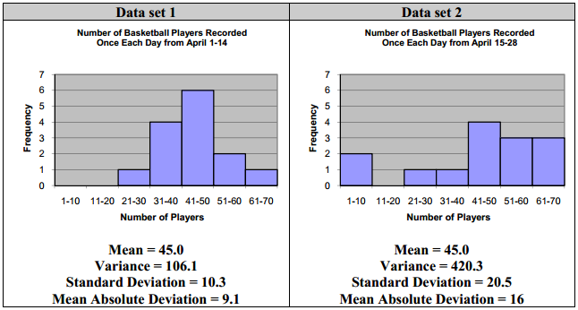

What types of inferences can be made about the data set with the given information?

Questions to explore with Algebra 1 students
- Given a frequency graph, a standard deviation of _______, and a mean of _______, how many elements fall within _______ standard deviation(s) from the mean? Why?
- Given the standard deviation and mean or mean absolute deviation and mean, which frequency graph would most likely represent the situation and why?
- Given two data sets with the same mean and different spreads, which one would best match a data set with a standard deviation or mean absolute deviation of _______? How do you know?
- Given two frequency graphs, explain why one might have a larger standard deviation.
- Given a data set with a mean of _______, a standard deviation of _______, and a z-score of _______, what is the value of the element associated with the z-score?
- What do z-scores tell you about position of elements with respect to the mean? How do z-scores relate to their associated element’s value?
- Given the standard deviation, the mean, and the value of an element of the data set, explain how you would find the associated z-score.
*** See Technical Assistance Document for Algebra 1 Application scenarios and calculator keystrokes ***
STATISTICS FOR ALGEBRA II

Types of Graphs:
Symmetric: Skewed Right: Skewed Left: Uniform:

Standard deviation is most commonly used when we talk about symmetric graphs. We use it for a special type of graph called a Normal Distribution.

- Much of the data in the world is symmetric. What are some examples of data that has a normal distribution?

- Normal curves are symmetric and bell shaped. They are centered on the mean. Pulse rates are normally distributed with a mean of 72 and a standard deviation of 12. We can use those numbers to label a normal model.
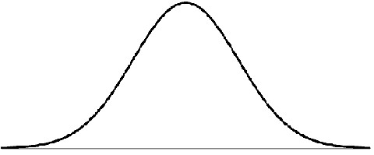

The 68-95-99.7% rule tells us that
- 68% of all people will have pulse rates within 1 standard deviation of the mean.
That means that 68% of people have pulse rates between __________ and __________.
- 95% of all people will have pulse rates within 2 standard deviations of the mean.
That means that 95 % of people have pulse rates between __________ and __________.
- 99.7% of all people will have pulse rates within 3 standard deviations of the mean.
That means that 99.7 % of people have pulse rates between __________ and __________.
Values outside of _______________________ or the __________ range are considered UNUSUAL.

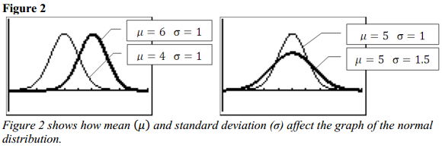
- Given a normally distributed data set of 500 observations measuring tree heights in a forest, what is the approximate number of observations that fall within two standard deviations from the mean?

- A normally distributed data set containing the number of ball bearings produced during a specified interval of time has a mean of 150 and a standard deviation of 10. What percentage of the observed values fall between 140 and 160?

Interpreting values from the table of Standard Normal Probabilities
A z-score associated with an element of a normal distribution is computed to be 1.23. The probability from the table of Standard Normal Probabilities associated with a z-score of 1.23 can be determined as indicated in Figure 4. The probability can be used differently based upon the context of the question.
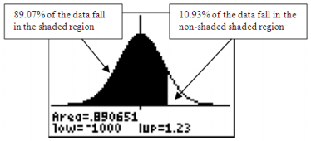
- The probability that a data value will fall below the data value associated with a z-score of 1.23 is 0.8907 (89.07%).
- The data value associated with a z-score of 1.23 falls in the 89th percentile. This means that 89 percent of the data in the distribution fall below the value associated with a z-score of 1.23. The probability that a value from the data set will fall above this value is 1 – 0.8907 = 0.1093 (10.93%).

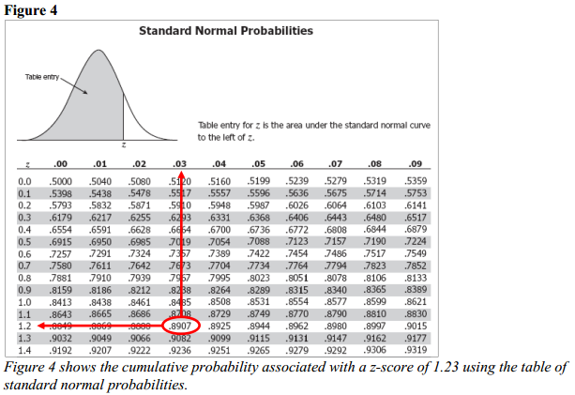

- Find P(x ≤ 9,000 hours) given µ = 10,000 and σ = 750.

- Amy took the ACT and scored a 27 on the mathematics portion of the test. For the ACT, the mean was 21 and the standard deviation was 5.3. What percent of the population scored higher than Amy on the mathematics portion of the ACT?

*** See Technical Assistance Document for Algebra 2 for calculator keystrokes ***

Explorations with Algebra 2 students
Note: All exploration questions should be in the real-world context of normally distributed data sets.
- Given a normally distributed data set with a specified mean and standard deviation, explain how the number of values expected to be above or below a certain value can be determined.
- Given normally distributed data, explain how you can determine how many values or what percentage of values are expected to fall within one, two or three standard deviations of the mean.
- Compare and contrast graphs of normal distributions that have the same mean but different standard deviations or different means and the same standard deviation.
- Given a normally distributed data set with a specified mean and standard deviation, explain how to determine the probability and/or area under the curve for
  - an element that has a value greater than a given value;
  - an element that has a value less than a given value; or
  - an element that has a value between two given values.
- Given the mean and standard deviation of two different normally distributed data sets, and a value from each data set, compare the values using their corresponding z-scores and percentiles.
- Given normally distributed data with specified mean and standard deviation, determine the probability that a randomly selected value will have a z-score within a certain range of values.

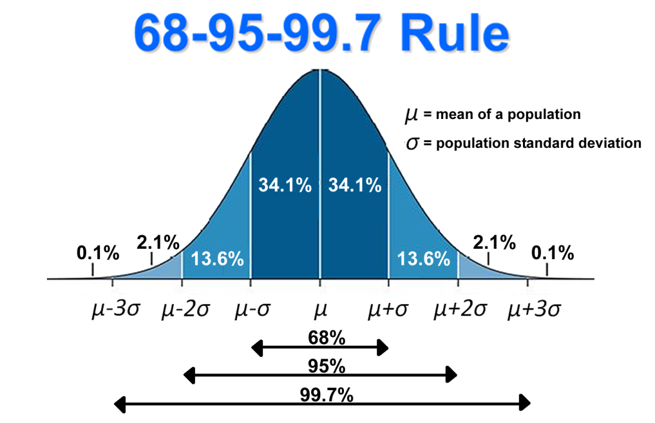

Name__________________________________

Record your pulse rate: _________________________

 | Pulse Rate (x) | Deviation (x - µ) | Absolute Deviation |(x - µ)| | Square of Deviation (x - µ)²
1
2
3
4
5
6
7
8
9
10
11
12
13
14
15
Mean (µ)
 |  |  | Mean Absolute Deviation | Variance |  | Standard Deviation

